|  |  |  |
| --- | --- | --- |
|  |  |  |
|  |  |  |

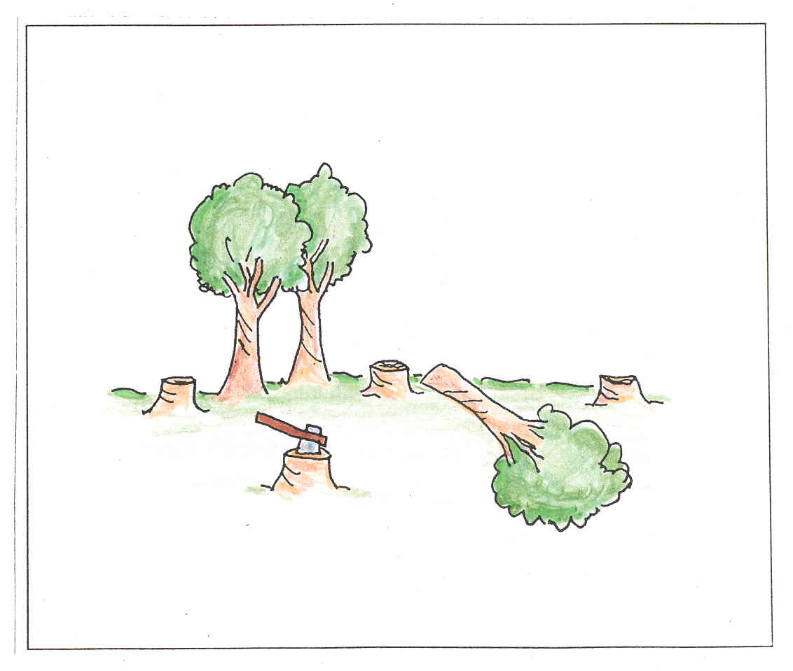

**Muorrameahccái:**

ákšu

báddi

sahá

traktor

maŋŋejorri

stuoraniibi

|  |  |  |
| --- | --- | --- |
|  |  |  |
|  |  |  |

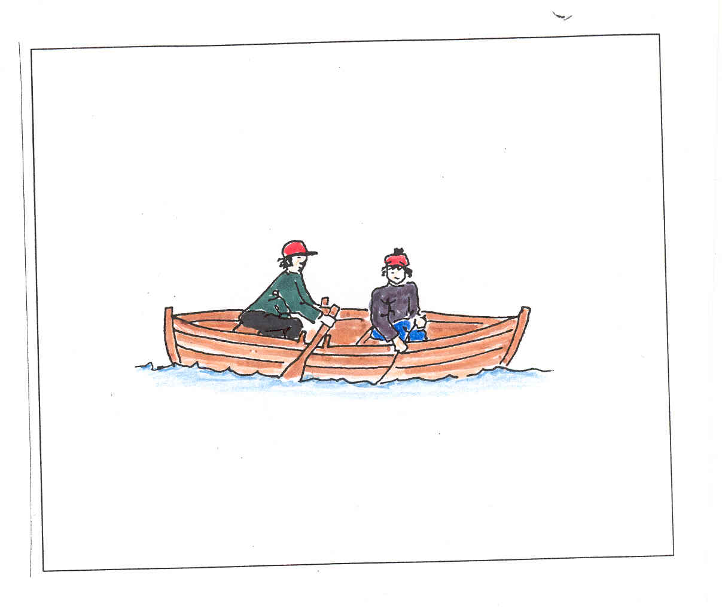

**Mearrabivdui:**

ávskár

giehtaváđđu

liehppi

fanas

vuogga

reaggá

|  |  |  |
| --- | --- | --- |
|  |  |  |
|  |  |  |

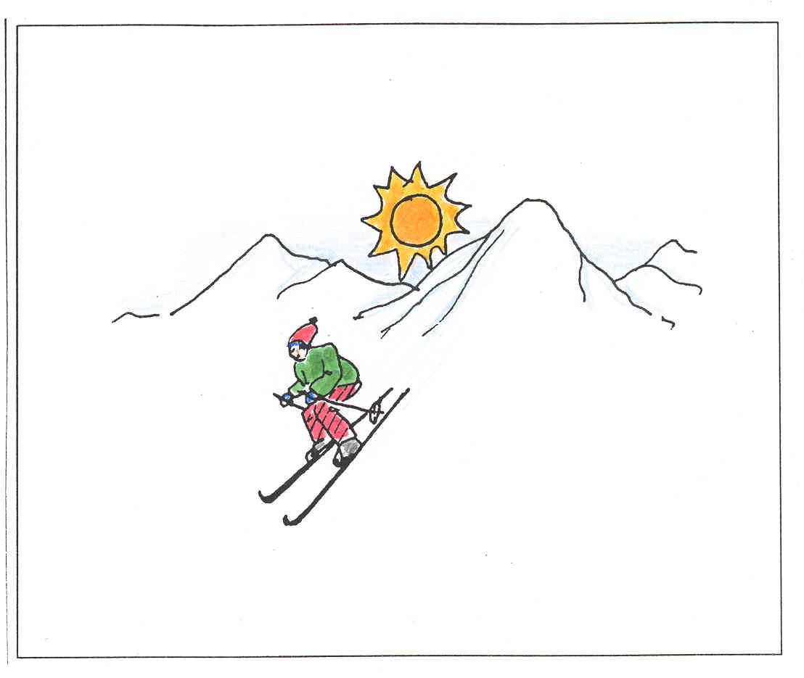

**Čuoiganmátkái:**

soappit

sabetvuoiddas

duollji

niesti

sabehat

gáffetermos

|  |  |  |
| --- | --- | --- |
|  |  |  |
|  |  |  |

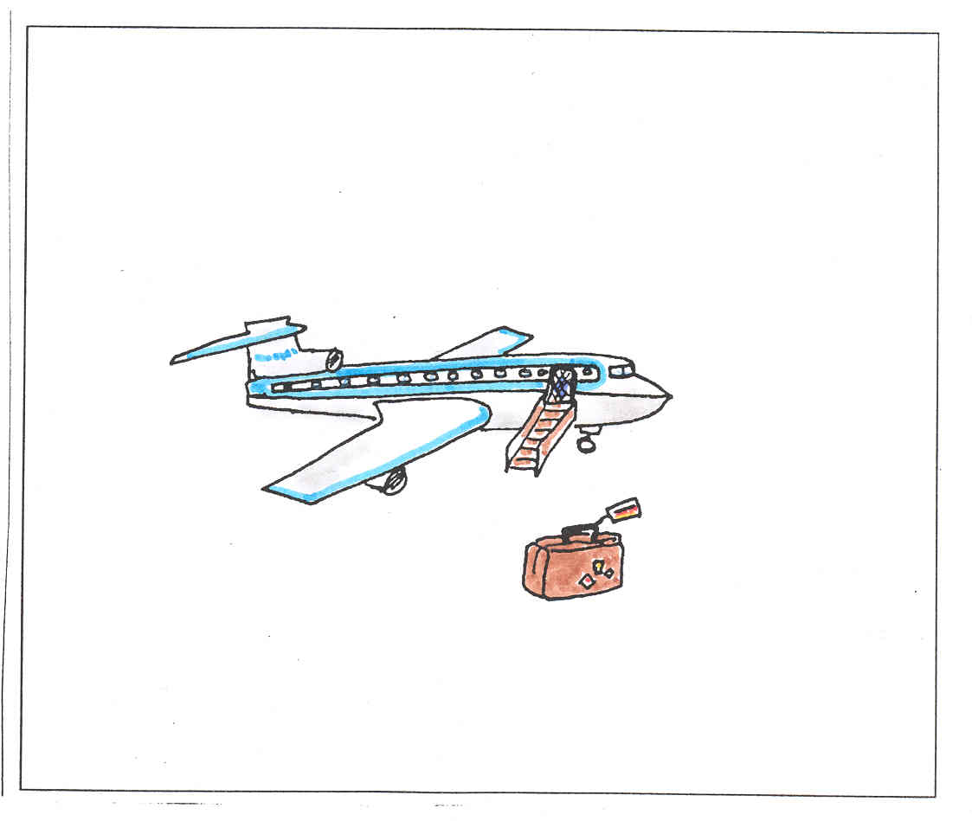

**Lupmui:**

čogu

beaivváščalbmelásat

beaivvášvuoiddas

dálkasat

sihkaldat

vuojadanbivttas

|  |  |  |
| --- | --- | --- |
|  |  |  |
|  |  |  |

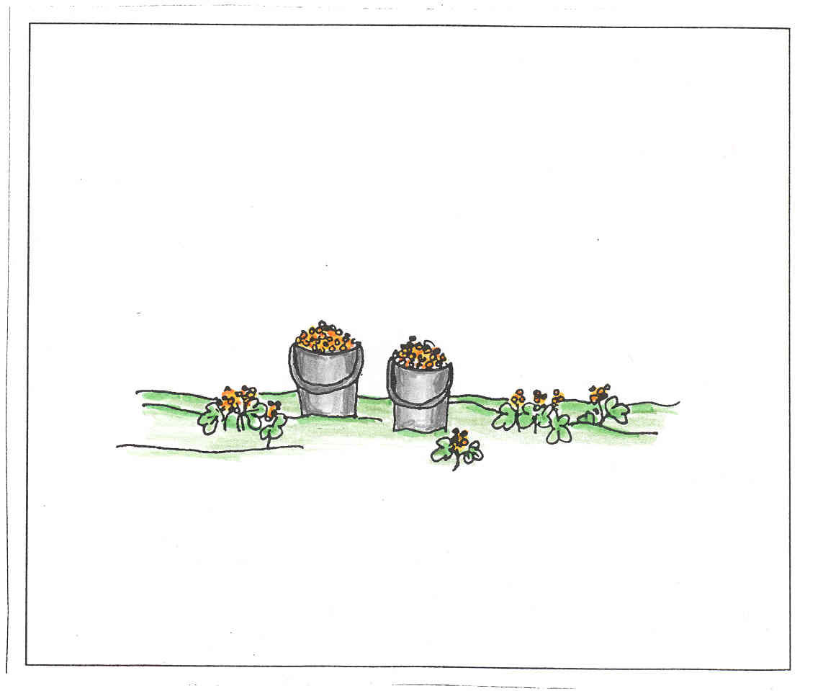

**Muorjemeahccái:**

lihtti

guksi

muorječoaggi

lávka

riššat

stevvelat

|  |  |  |
| --- | --- | --- |
|  |  |  |
|  |  |  |

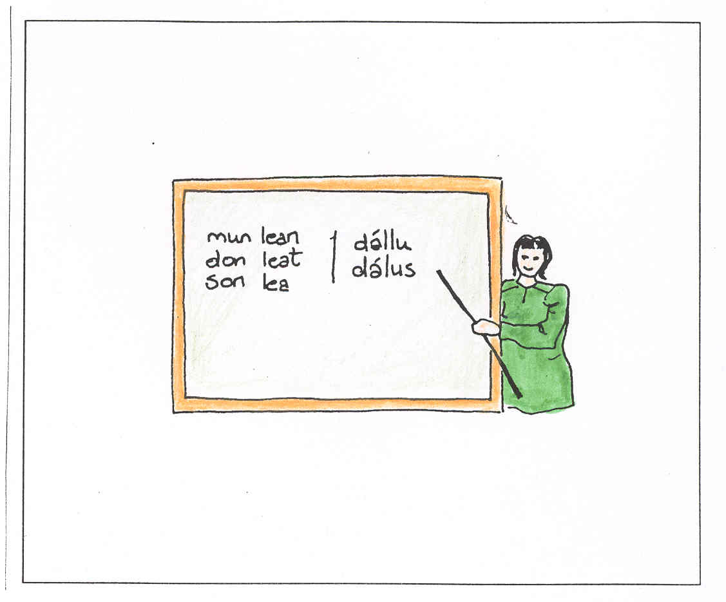

**Sámegielgursii:**

čalbmelásat

čállingirji

oahppogirji

sátnegirji

giehtadiibmu

lianta ja sihkkun-gumme

|  |  |  |
| --- | --- | --- |
|  |  |  |
|  |  |  |

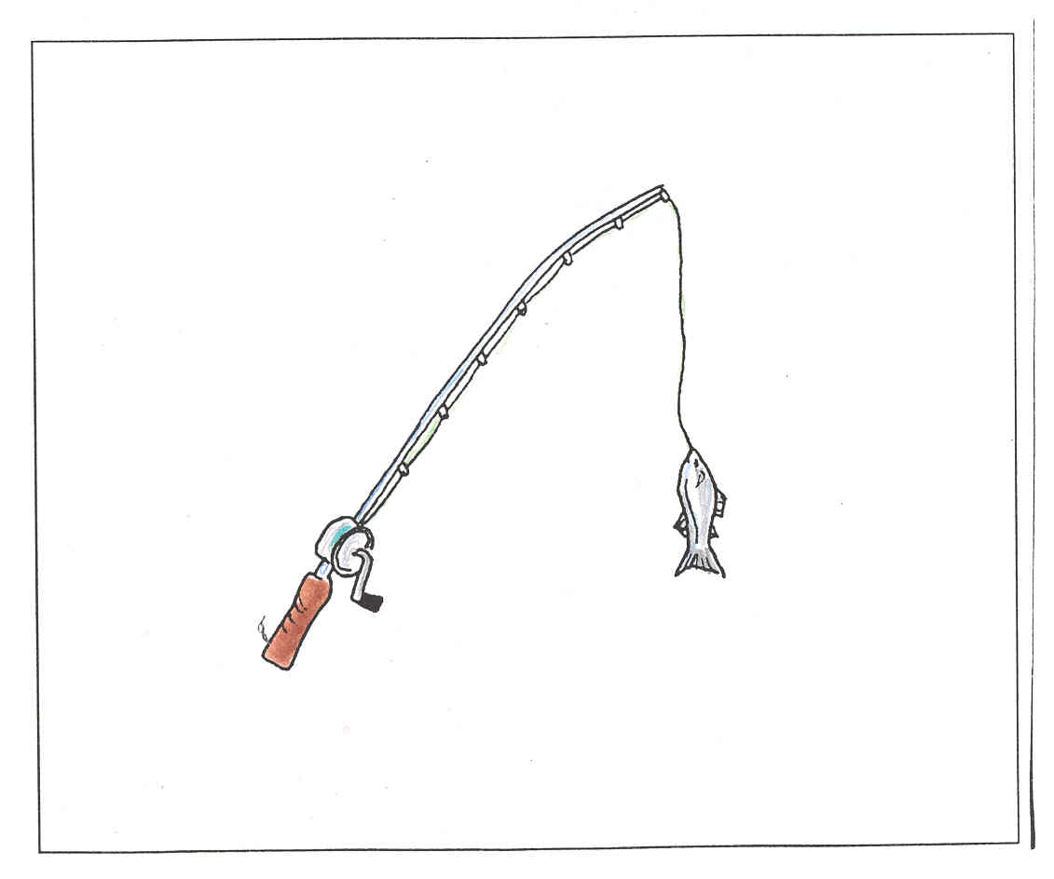

**Jávrebivdui:**

lávvu

niibi

oađđenseahkka

stággu

vuodjaskáhppu

arvebivttas

|  |  |  |
| --- | --- | --- |
|  |  |  |
|  |  |  |

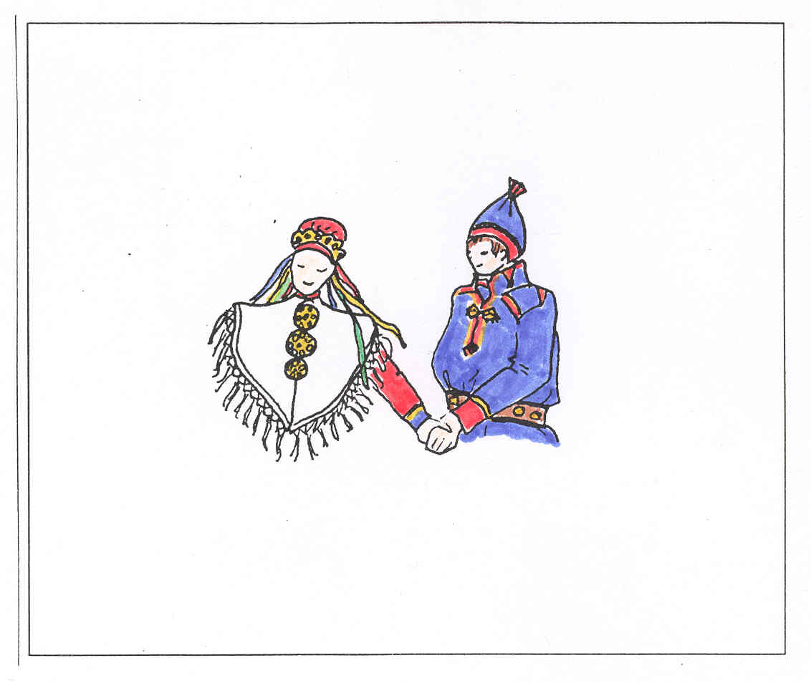

**Heajaide:**

gákti

gápmagat

boagán

risku

liidni

skeaŋka

|  |  |  |
| --- | --- | --- |
|  |  |  |
|  |  |  |

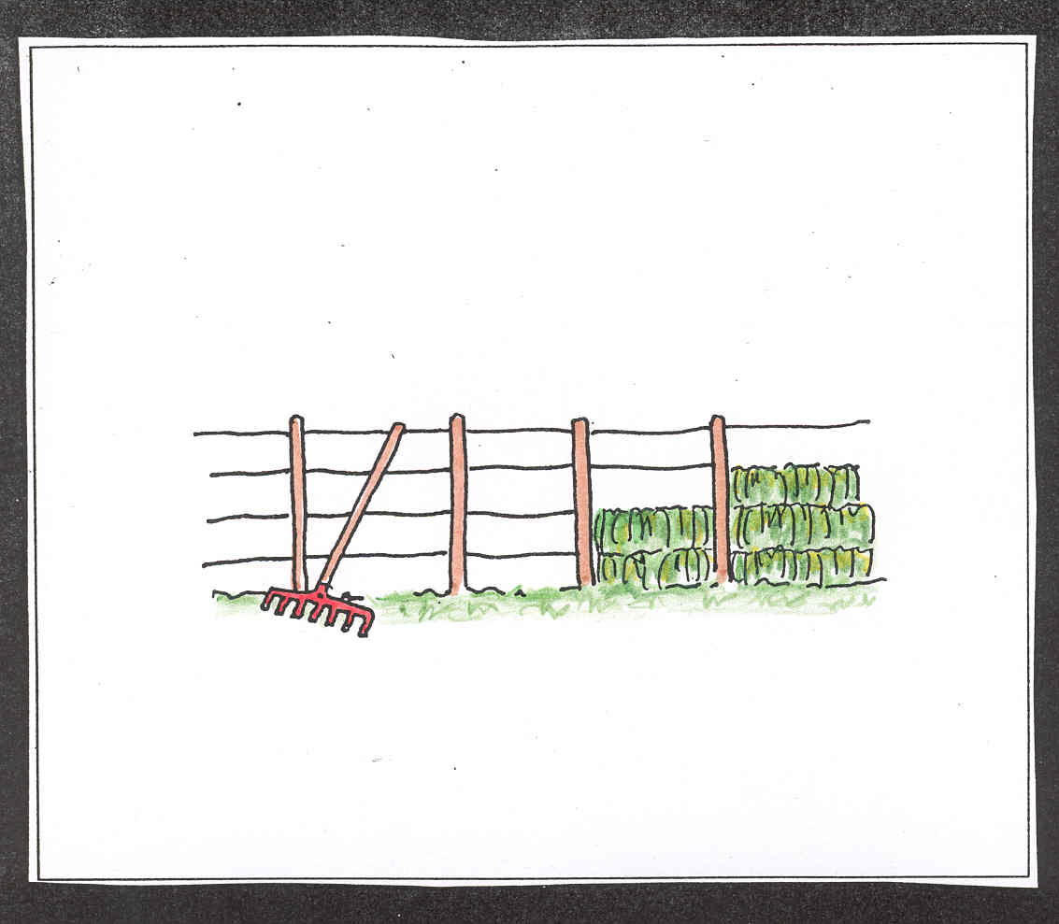

**Ládjui:**

biigá

riifu

liššá

návllit

gáfegievdni

veažir

|  |  |  |
| --- | --- | --- |
|  |  |  |
|  |  |  |

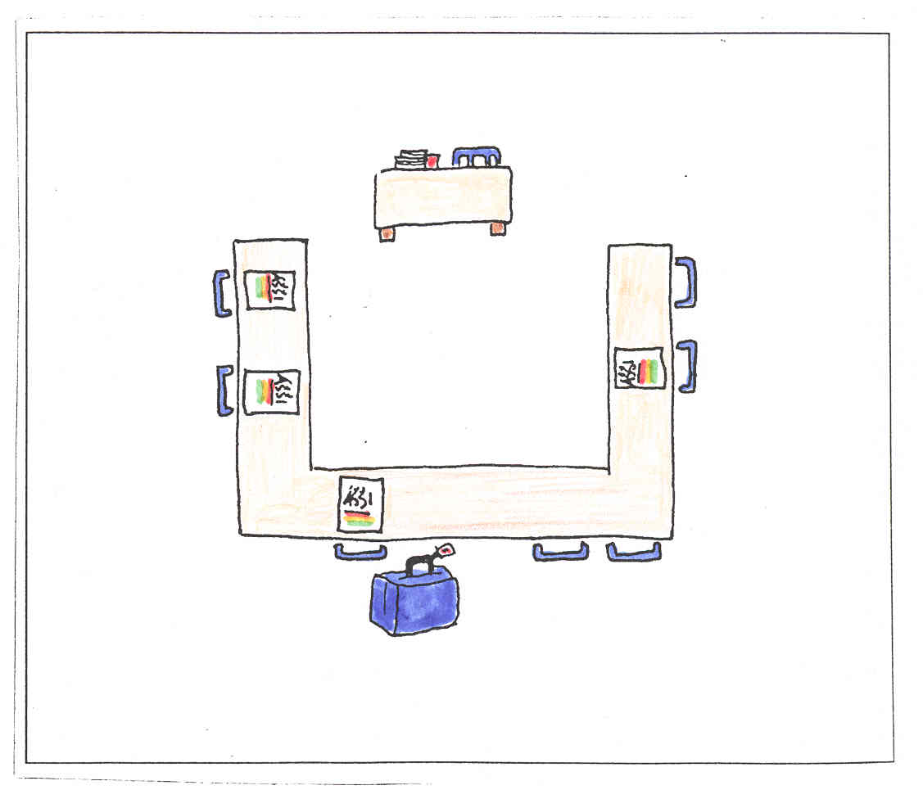

**Čoahkkimii:**

áššebáhpárat

bursa

mátkedihtor

mobiltelefovdna

koaffar

peanna